**May 7_9 Lab questions**

#1. WAP to find the LCM of two numbers a and b by using a suitable function

(say LCM) for this.

Code:

#include <stdio.h>

void LCM(int a_285,int b_285)

{

    int i_285,result_285;

    for(i_285=1;i_285<5000;i_285++)

    {

        if(i_285%a_285==0 && i_285%b_285==0)

        {

            printf("LCM of %d and %d is %d\n",a_285,b_285,i_285);

            break;

        }

    }

}

int main()

{

    int a_285,b_285;

    printf("Please provide the two numbers\n");

    scanf("%d%d",&a_285,&b_285);

    LCM(a_285,b_285);

    return 0;

}

Output:

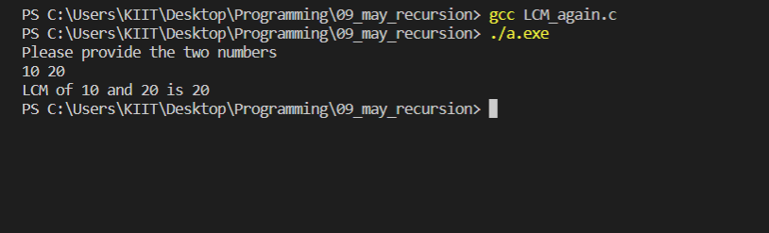

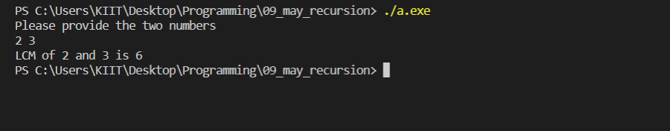

#2. WAP to find out the sum of n elements of an integer array a[] by using

recursion.

Code:

#include <stdio.h>

int SUM(int A_285[],int n_285)

{

    int sum_285,b;

    if(n_285==0)

    {

        return A_285[0];

    }

    else

    {

        sum_285=A_285[n_285]+SUM(A_285,n_285-1);

    }

    return sum_285;

}

int main()

{

    int i,A_285[30],num_285,sum_285;

    printf("Please provide the number of your elements\n_285");

    scanf("%d",&num_285);

    printf("Please provide the elements of your list\n_285");

    for(i=0;i<num_285;i++)

    {

        scanf("%d",&A_285[i]);

    }

    sum_285=SUM(A_285,num_285-1);

    printf("The sum of your elements is %d\n_285",sum_285);

}

Output:

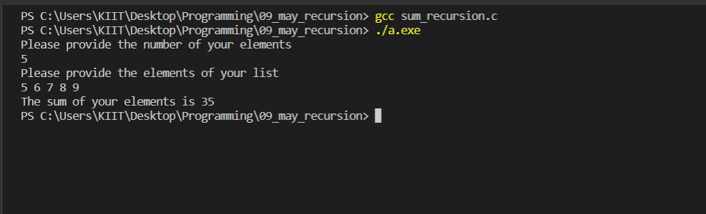

#3. WAP by designing a recursive function to calculate the sum of all even

digits of any given integer.

Code:

#include <stdio.h>

int SUM(int count_285, int arr_285[])

{

    int i,total;

    if(count_285<=0)

        return 0;

    total= arr_285[count_285-1]+SUM(count_285-1,arr_285);

    return total;

}

int main()

{

    int num_285,sum,arr_285[20],i,rem_285,count_285;

    printf("Please provide an integer\n");

    scanf("%d",&num_285);

    for(i=0;num_285!=0;)

    {

        rem_285=num_285%10;

        if(rem_285%2==0)

        {

            arr_285[i]=rem_285;

            count_285++;

            i++;

        }

        num_285=num_285/10;

    }

    sum=SUM(count_285,arr_285);

    printf("The sum of the digits in your integer is %d\n",sum);

    return 0;

}

Output:

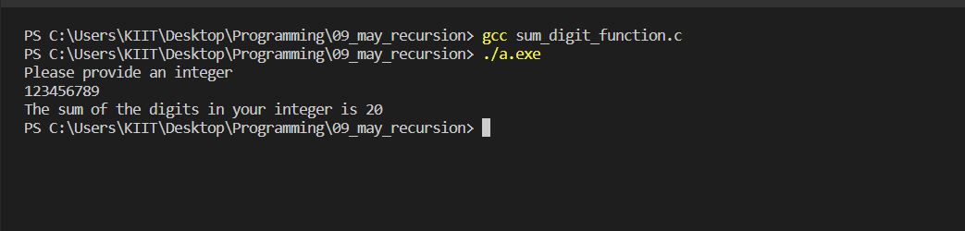

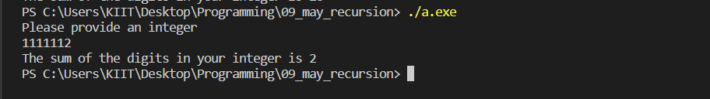

#4. WAP to generate the first n terms of the sequence by writing a suitable

user defined function (say fib) to be used to get nth term Fibonacci value.

Code:

#include <stdio.h>

void fib(int n)

{

    int term1_285,term2_285,term3_285,i,fibn[100];

    term1_285=0;

    fibn[0]=term1_285;

    term2_285=1;

    fibn[1]=term2_285;

    term3_285=term1_285+term2_285;

    for(i=2;i<n;i++)

    {

        fibn[i]=fibn[i-1]+fibn[i-2];

    }

    for(i=0;i<n;i++)

    {

        printf("%d ",fibn[i]);

    }

}

int main()

{

    int n;

    printf("Provide the number of fibonacci terms u want=\n");

    scanf("%d",&n);

    fib(n);

    return 0;

}

Output:

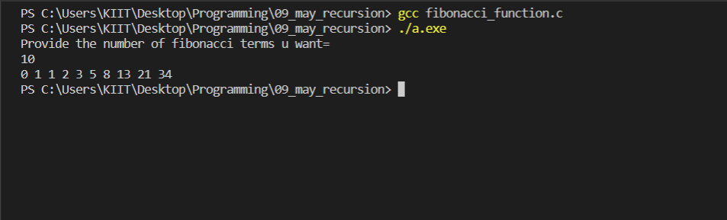

#5. WAP to change the value of constant integer using pointers.

Code:

#include <stdio.h>

int main()

{

    const float pi_285=3.14;

    float *ptr_285;

    ptr_285=&pi_285;

    printf("The value of pi is %f\n",*ptr_285);

    printf("But its okay, give your own desired value to pi\n");

    scanf("%f",ptr_285);

    printf("=-=-==-=-=-=-=-=-=-==-=-=-=-=-=-\n");

    printf("The new value you have given is = %f\n",*ptr_285);

    printf("=-=-==-=-=-=-=-=-=-==-=-=-=-=-=-\n");

    return 0;

}

Output:

